WEB ENUMERATION AND HIDDEN FLAG DISCOVERY

PROOF OF CONCEPT

Step 1:
The question paper could not be downloaded directly, so that browser’s Inspect Element was used. By examining the HTML <img> tag, the source path of the image file was identified.
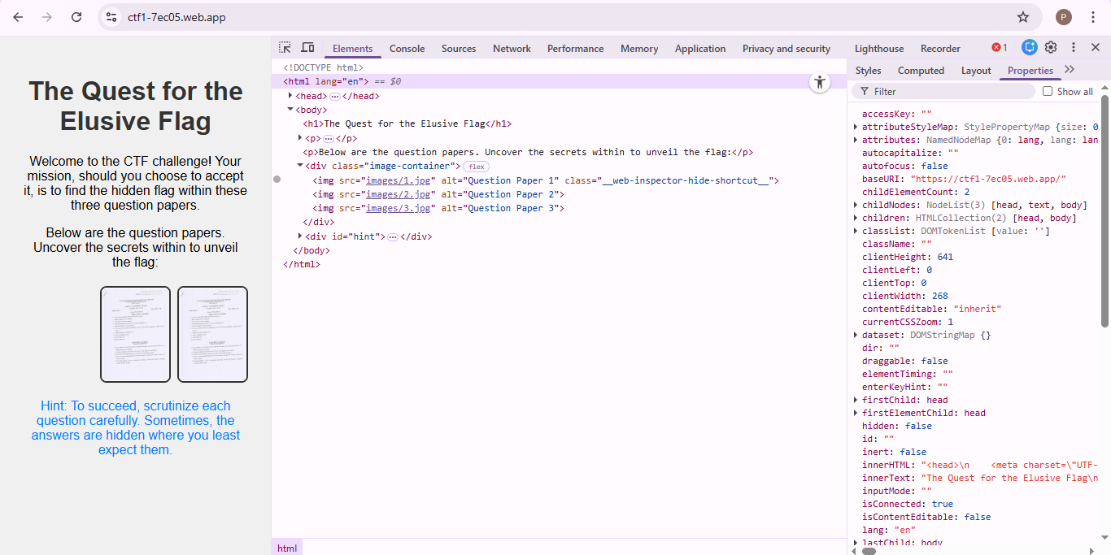

Step 2:
The image source URL (/images/1.jpg) was copied and opened in a new browser tab.

Step 3:
Open a different browser and then the image number in the URL was manually changed to access other files:
2.jpg , 3.jpg , 4.jpg

Step 4:
While 1.jpg, 2.jpg, and 3.jpg contained question papers, 4.jpg displayed hidden content instead of a paper, revealing the flag.

Step 5:
The final flag was obtained in the standard CTF format and submitted as:
FLAG{H1iJ2kL3mN4oP5qR6s}

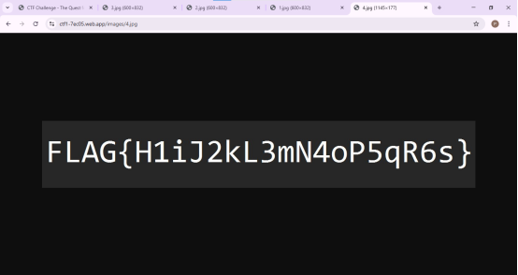

REVERSE SHELL USING METASPLOIT

PROOF OF CONCEPT

Step 1:
The first step was to find the target machine on the network. Scanning was performed to identify active hosts and open ports. The results showed that the target machine had SSH (port 22) and HTTP (port 80) services running.
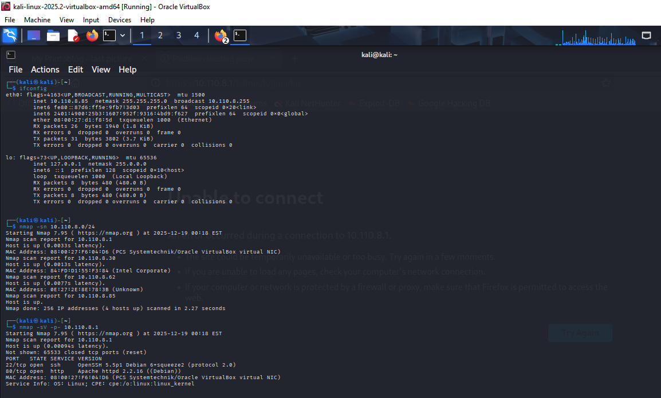

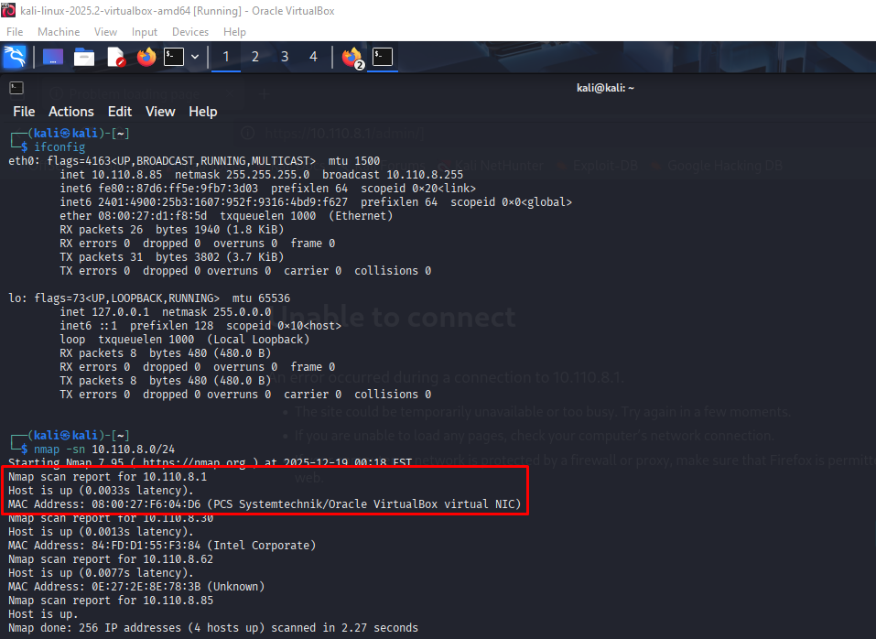

Step 2:
After identifying open ports, the running services were analyzed. The SSH service was found to be running an older version, and the web server was using Apache with PHP, which could contain vulnerabilities.

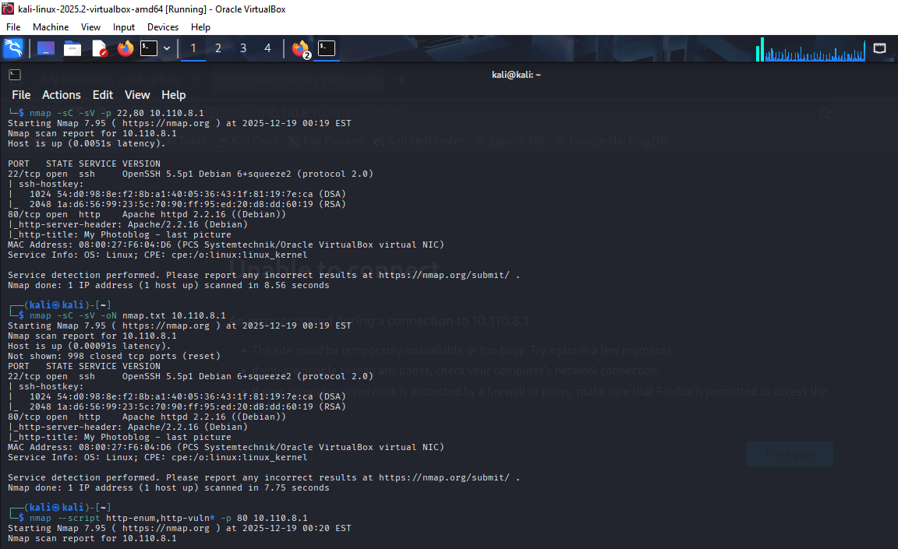

Step 3:
Directory enumeration was conducted on the web server to discover hidden paths. Several important directories such as /admin, /admin/login, /admin/uploads, and /cgi-bin were found. These directories suggested the presence of an administrative panel and potential web-based attack vectors.
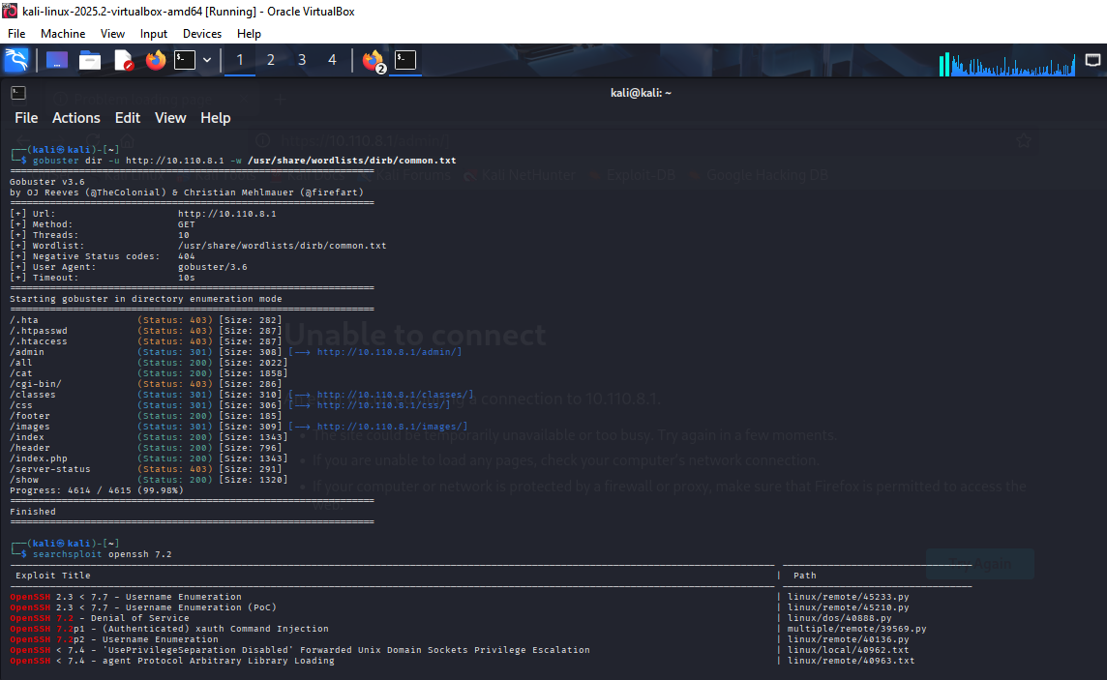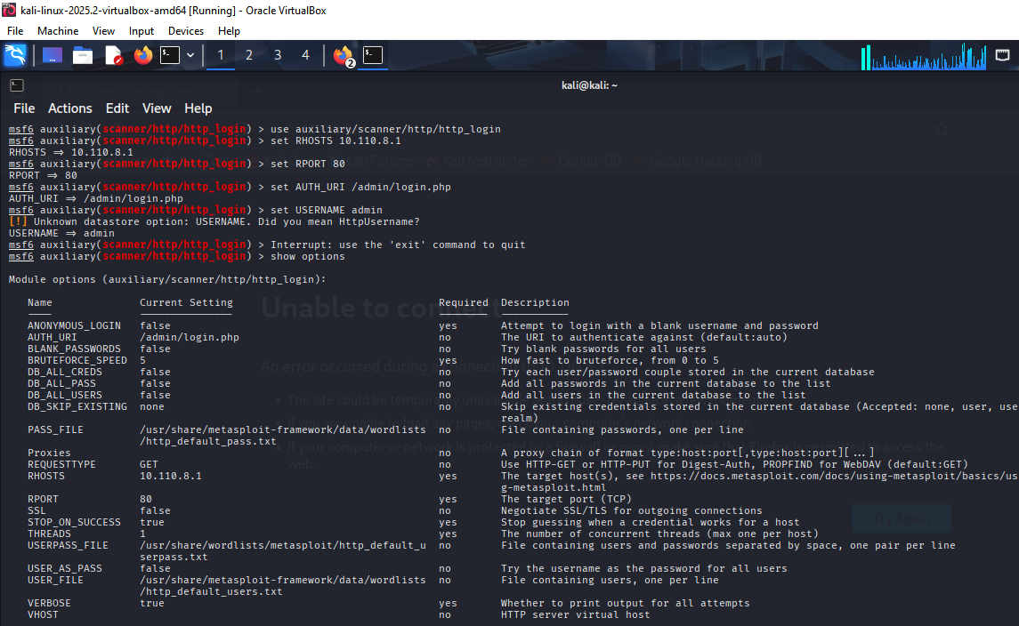

Step 4:
The admin login page was examined to understand how authentication worked. It was identified as a form-based login page, not HTTP authentication. This indicated that brute-forcing HTTP authentication would not work, and other vulnerabilities needed to be tested.
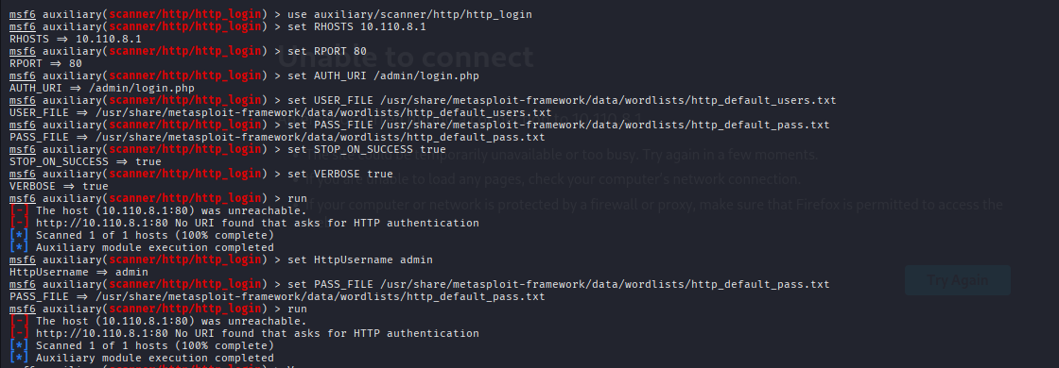

Step 5:
Based on the findings, the attack approach focused on exploiting web application vulnerabilities to gain access to the system. After gaining access, privilege escalation techniques would be used to obtain full control of the target machine.

